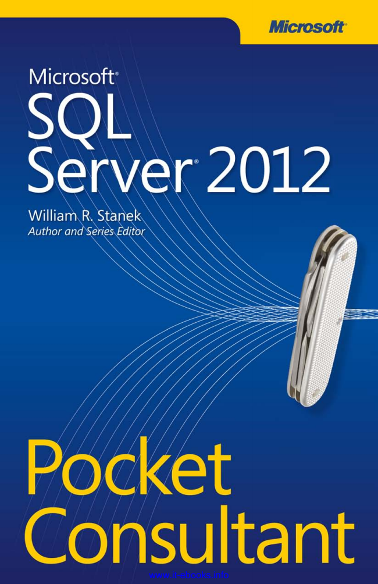

www.it-ebooks.info

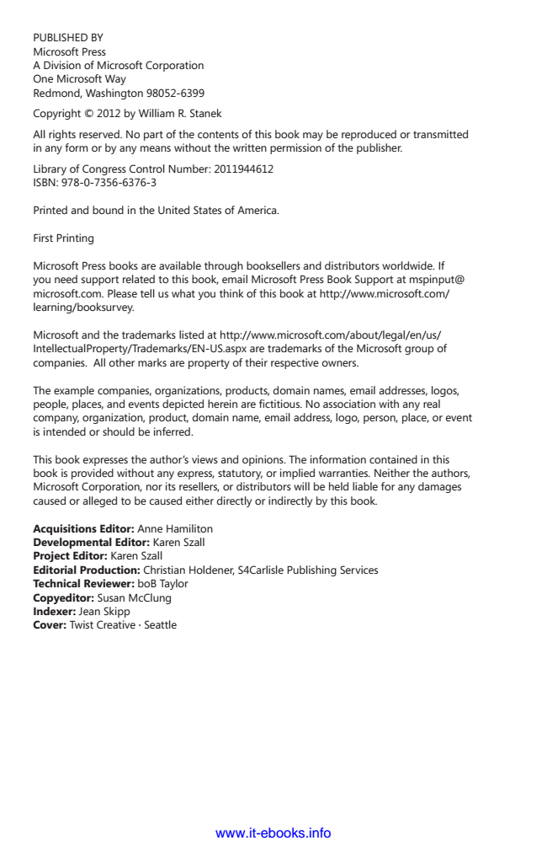

PUBLISHED BY Microsoft Press A Division of Microsoft Corporation One Microsoft Way Redmond, Washington 98052-6399

Copyright © 2012 by William R. Stanek

All rights reserved. No part of the contents of this book may be reproduced or transmitted in any form or by any means without the written permission of the publisher.

Library of Congress Control Number: 2011944612 ISBN: 978-0-7356-6376-3

Printed and bound in the United States of America.

First Printing

Microsoft Press books are available through booksellers and distributors worldwide. If you need support related to this book, email Microsoft Press Book Support at mspinput@ microsoft.com. Please tell us what you think of this book at http://www.microsoft.com/ learning/booksurvey.

Microsoft and the trademarks listed at http://www.microsoft.com/about/legal/en/us/ IntellectualProperty/Trademarks/EN-US.aspx are trademarks of the Microsoft group of companies. All other marks are property of their respective owners.

The example companies, organizations, products, domain names, email addresses, logos, people, places, and events depicted herein are fictitious. No association with any real company, organization, product, domain name, email address, logo, person, place, or event is intended or should be inferred.

This book expresses the author’s views and opinions. The information contained in this book is provided without any express, statutory, or implied warranties. Neither the authors, Microsoft Corporation, nor its resellers, or distributors will be held liable for any damages caused or alleged to be caused either directly or indirectly by this book.

Acquisitions Editor: Anne Hamiliton Developmental Editor: Karen Szall Project Editor: Karen Szall Editorial Production: Christian Holdener, S4Carlisle Publishing Services Technical Reviewer: boB Taylor Copyeditor: Susan McClung Indexer: Jean Skipp Cover: Twist Creative ∙ Seattle

www.it-ebooks.info



*To my wife—for many years, through many books, many millions of words, and many thousands of pages, she's been there, providing support and encouragement and making every place we've lived a home.*

*To my kids—for helping me see the world in new ways, for having exceptional patience and boundless love, and for making every day an adventure.*

*To Karen, Martin, Lucinda, Juliana, Ben, and many others who’ve helped out in ways both large and small.*

—W

illiam

R. S

tanek

www.it-ebooks.info



www.it-ebooks.info

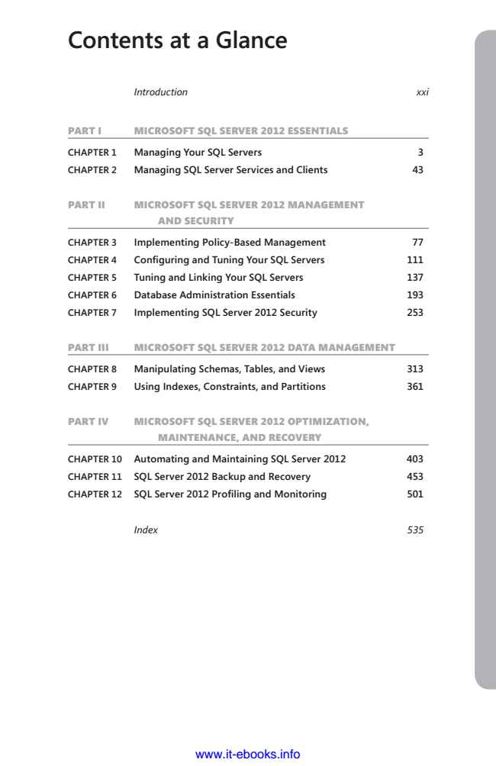

**Contents at a Glance**

*Introduction xxi*

PART I MICROSOFT SQL SERVER 2012 ESSENTIALS

**CHAPTER 1 Managing Your SQL Servers 3**

**CHAPTER 2 Managing SQL Server Services and Clients 43**

PART II MICROSOFT SQL SERVER 2012 MANAGEMENT

AND SECURITY

**CHAPTER 3 Implementing Policy-Based Management 77**

**CHAPTER 4 Configuring and Tuning Your SQL Servers 111**

**CHAPTER 5 Tuning and Linking Your SQL Servers 137**

**CHAPTER 6 Database Administration Essentials 193**

**CHAPTER 7 Implementing SQL Server 2012 Security 253**

PART III MICROSOFT SQL SERVER 2012 DATA MANAGEMENT

**CHAPTER 8 Manipulating Schemas, Tables, and Views 313**

**CHAPTER 9 Using Indexes, Constraints, and Partitions 361**

PART IV MICROSOFT SQL SERVER 2012 OPTIMIZATION,

MAINTENANCE, AND RECOVERY

**CHAPTER 10 Automating and Maintaining SQL Server 2012 403**

**CHAPTER 11 SQL Server 2012 Backup and Recovery 453**

**CHAPTER 12 SQL Server 2012 Profiling and Monitoring 501**

*Index 535*

www.it-ebooks.info



www.it-ebooks.info

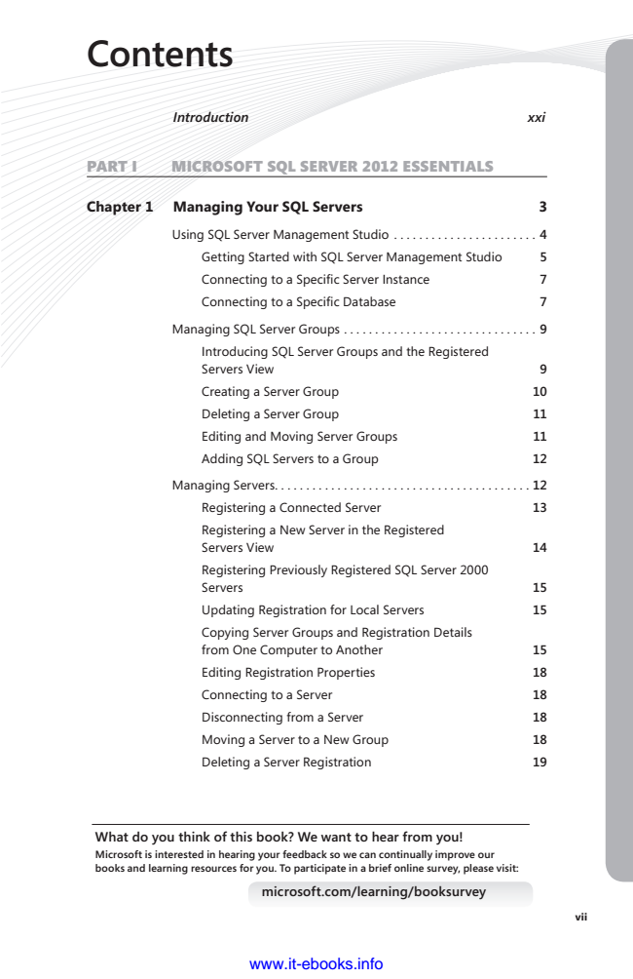

**Contents**

***Introduction xxi***

PART I MICROSOFT SQL SERVER 2012 ESSENTIALS

**Chapter 1 Managing Your SQL Servers 3**

Using SQL Server Management Studio . . . . . . . . . . . . . . . . . . . . . . . 4

Getting Started with SQL Server Management Studio 5

Connecting to a Specific Server Instance 7

Connecting to a Specific Database 7

Managing SQL Server Groups . . . . . . . . . . . . . . . . . . . . . . . . . . . . . . . 9

Introducing SQL Server Groups and the Registered Servers View 9

Creating a Server Group 10

Deleting a Server Group 11

Editing and Moving Server Groups 11

Adding SQL Servers to a Group 12

Managing Servers . . . . . . . . . . . . . . . . . . . . . . . . . . . . . . . . . . . . . . . . . 12

Registering a Connected Server 13

Registering a New Server in the Registered Servers View 14

Registering Previously Registered SQL Server 2000 Servers 15

Updating Registration for Local Servers 15

Copying Server Groups and Registration Details from One Computer to Another 15

Editing Registration Properties 18

Connecting to a Server 18

Disconnecting from a Server 18

Moving a Server to a New Group 18

Deleting a Server Registration 19

**What do you think of this book? We want to hear from you! Microsoft is interested in hearing your feedback so we can continually improve our books and learning resources for you. To participate in a brief online survey, please visit:**

**microsoft.com/learning/booksurvey**

www.it-ebooks.info

**vii**

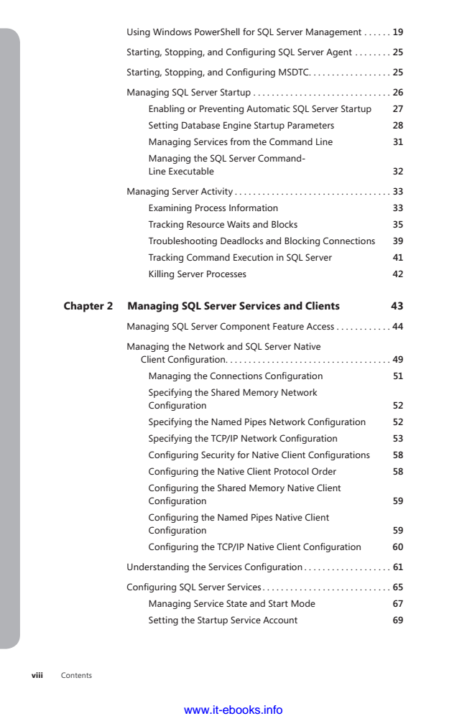

Using Windows PowerShell for SQL Server Management . . . . . . 19

Starting, Stopping, and Configuring SQL Server Agent ........ 25

Starting, Stopping, and Configuring MSDTC .................. 25

Managing SQL Server Startup . . . . . . . . . . . . . . . . . . . . . . . . . . . . . . 26

Enabling or Preventing Automatic SQL Server Startup 27

Setting Database Engine Startup Parameters 28

Managing Services from the Command Line 31

Managing the SQL Server Command- Line Executable 32

Managing Server Activity . . . . . . . . . . . . . . . . . . . . . . . . . . . . . . . . . . 33

Examining Process Information 33

Tracking Resource Waits and Blocks 35

Troubleshooting Deadlocks and Blocking Connections 39

Tracking Command Execution in SQL Server 41

Killing Server Processes 42

**Chapter 2 Managing SQL Server Services and Clients 43**

Managing SQL Server Component Feature Access . . . . . . . . . . . . 44

Managing the Network and SQL Server Native

Client Configuration .................................... 49

Managing the Connections Configuration 51

Specifying the Shared Memory Network Configuration 52

Specifying the Named Pipes Network Configuration 52

Specifying the TCP/IP Network Configuration 53

Configuring Security for Native Client Configurations 58

Configuring the Native Client Protocol Order 58

Configuring the Shared Memory Native Client Configuration 59

Configuring the Named Pipes Native Client Configuration 59

Configuring the TCP/IP Native Client Configuration 60

Understanding the Services Configuration ................... 61

Configuring SQL Server Services ............................ 65

Managing Service State and Start Mode 67

Setting the Startup Service Account 69

viii Contents

www.it-ebooks.info

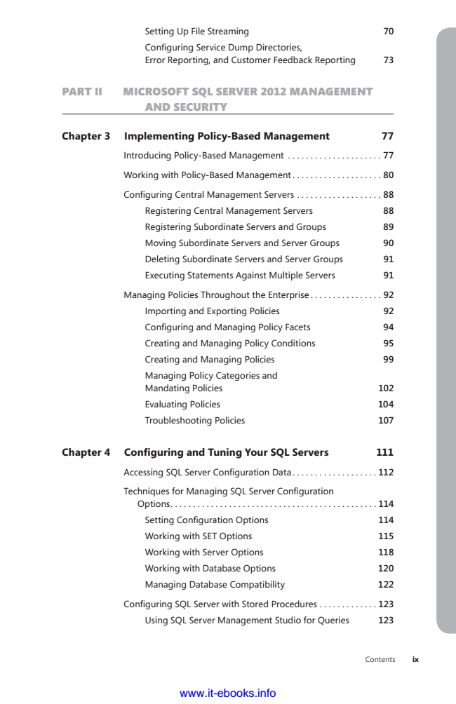

Setting Up File Streaming 70

Configuring Service Dump Directories, Error Reporting, and Customer Feedback Reporting 73

PART II MICROSOFT SQL SERVER 2012 MANAGEMENT

AND SECURITY

**Chapter 3 Implementing Policy-Based Management 77**

Introducing Policy-Based Management . . . . . . . . . . . . . . . . . . . . . 77

Working with Policy-Based Management . . . . . . . . . . . . . . . . . . . . 80

Configuring Central Management Servers ................... 88

Registering Central Management Servers 88

Registering Subordinate Servers and Groups 89

Moving Subordinate Servers and Server Groups 90

Deleting Subordinate Servers and Server Groups 91

Executing Statements Against Multiple Servers 91

Managing Policies Throughout the Enterprise . . . . . . . . . . . . . . . . 92

Importing and Exporting Policies 92

Configuring and Managing Policy Facets 94

Creating and Managing Policy Conditions 95

Creating and Managing Policies 99

Managing Policy Categories and Mandating Policies 102

Evaluating Policies 104

Troubleshooting Policies 107

**Chapter 4 Configuring and Tuning Your SQL Servers 111**

Accessing SQL Server Configuration Data ................... 112

Techniques for Managing SQL Server Configuration

Options . . . . . . . . . . . . . . . . . . . . . . . . . . . . . . . . . . . . . . . . . . . . . . 114

Setting Configuration Options 114

Working with SET Options 115

Working with Server Options 118

Working with Database Options 120

Managing Database Compatibility 122

Configuring SQL Server with Stored Procedures ............. 123

Using SQL Server Management Studio for Queries 123

www.it-ebooks.info

Contents

**ix**

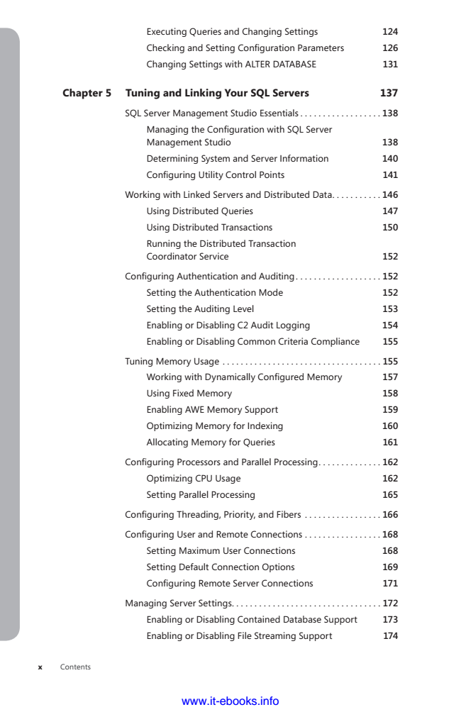

Executing Queries and Changing Settings 124

Checking and Setting Configuration Parameters 126

Changing Settings with ALTER DATABASE 131

**Chapter 5 Tuning and Linking Your SQL Servers 137**

SQL Server Management Studio Essentials . . . . . . . . . . . . . . . . . . 138

Managing the Configuration with SQL Server Management Studio 138

Determining System and Server Information 140

Configuring Utility Control Points 141

Working with Linked Servers and Distributed Data . . . . . . . . . . . 146

Using Distributed Queries 147

Using Distributed Transactions 150

Running the Distributed Transaction Coordinator Service 152

Configuring Authentication and Auditing ................... 152

Setting the Authentication Mode 152

Setting the Auditing Level 153

Enabling or Disabling C2 Audit Logging 154

Enabling or Disabling Common Criteria Compliance 155

Tuning Memory Usage . . . . . . . . . . . . . . . . . . . . . . . . . . . . . . . . . . . 155

Working with Dynamically Configured Memory 157

Using Fixed Memory 158

Enabling AWE Memory Support 159

Optimizing Memory for Indexing 160

Allocating Memory for Queries 161

Configuring Processors and Parallel Processing .............. 162

Optimizing CPU Usage 162

Setting Parallel Processing 165

Configuring Threading, Priority, and Fibers ................. 166

Configuring User and Remote Connections ................. 168

Setting Maximum User Connections 168

Setting Default Connection Options 169

Configuring Remote Server Connections 171

Managing Server Settings . . . . . . . . . . . . . . . . . . . . . . . . . . . . . . . . . 172

Enabling or Disabling Contained Database Support 173

Enabling or Disabling File Streaming Support 174

x Contents

www.it-ebooks.info